Black Lives Matter marchers in downtown Winston-Salem
By Jordan Howse Winston-Salem Journal: Sunday, July 10, 2016

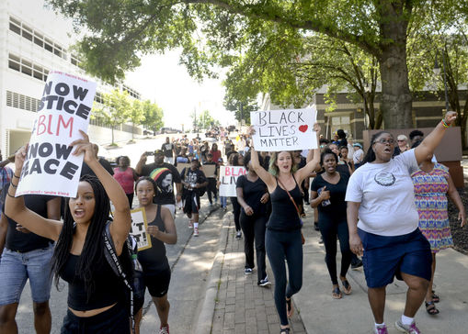 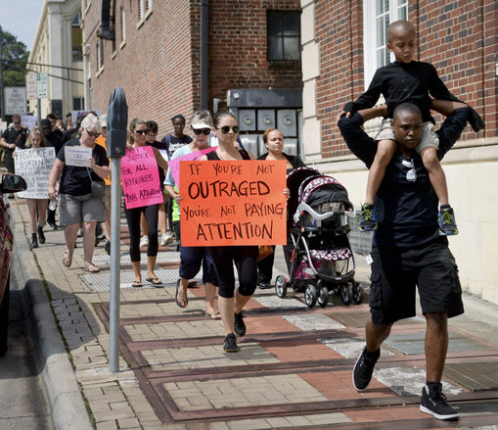 Journal photo: Amaris Carr speaks out! Journal photo: Diverse Marchers

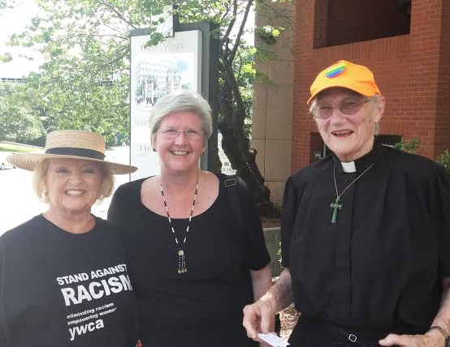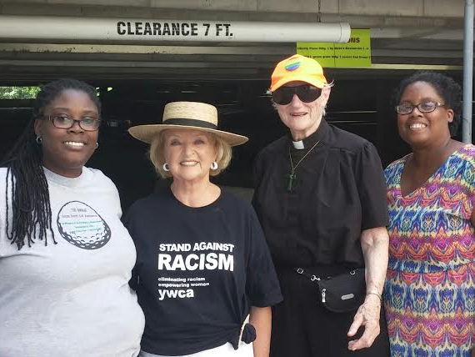
Arbor Acres resident Liz Vinson, Kim, Yar Amaris, Kim, Yar, Akwete

The line of marchers stretched for blocks during a demonstration through downtown Winston-Salem. Two high-profile police killings in Louisiana and Minnesota and the shooting deaths of five police officers in Dallas led Frankie Gist, the organizer of Saturday’s Black Lives Matter march, to a simple conclusion: Something needed to happen to show that black lives must be seen as equal in the eyes of police, and to promote peace.
Though Saturday’s march was planned prior to the killing of the Dallas officers, Gist said that the march was a demonstration against all violence. “It’s not just about black lives or Hispanic lives or a certain race. It’s about everybody,” Gist said. “There’s no use for gun violence against anyone.” The stretch of violence prompted Althea Ross to come to the march with her daughter and granddaughter. “We’re here to make a statement about the lives being lost for no reason whatsoever,” she said. “Black lives are treated differently than other lives. If you take a look at the way other people are treated as opposed to black people, that’s why I’m here. Changes have got to be made.”

1

For Janelle Pruitt, coming to the march with her mother, sister and son was a show of solidarity with black people and others slain by police. “I want my son to know and to understand that we are all one,” she said. “We are all people, and we should all be treated fairly.” Pruitt’s sister, Jenny, said she came to march with her family because something needed to be done. “It’s time to get off social media and take action,” she said. “I want to show our black community that we stand in solidarity with them and that this is not what America is about.”
The march started at Corpening Plaza and weaved through downtown for about 90 minutes. Winston-Salem police officers were on most street corners along the planned route of the march, but the route changed as the march accommodated people who joined at different points. Assistant Police Chief Wilson Weaver said the police were flexible with the route change. Motorcycle and bicycle officers rode along the improvised route to make sure everyone was safe, Weaver said. Officers did not expect confrontations with marchers, he said.
As the route changed, the primary concern became keeping vehicles away from the marchers. “We don’t want anyone to get run over,” Weaver said. “The organizers told us from the beginning that they wanted a peaceful march, so we weren’t anticipating any problems from them. They’ve been thanking us for our assistance as they marched.”
There were no issues with counter-protests.
Talia Groom said she is always appreciative of the police in Winston-Salem.
“Every city has its issues, but Winston is pretty good about (police) being out in the community,” she said. “I think that helps a lot when it comes to having things like this happen.”
Weaver said he thinks that building relationships with the community is key to prevent shootings like the ones in other cities this week. “We feel in Winston-Salem that our relationship with our community is far and above what we’ve seen in other communities, and we’re working to improve that every day,” he said. The police department hosts trust talks around the city to continue to build relationships in different communities.
Police Chief Barry Rountree said the shootings spurred an outpouring of support for police. “We’ve had different groups drop off things, and I’ve received calls, texts and emails from people saying that they’re praying for WSPD and the country in general,” Rountree said. “It’s a tough situation for everybody. Any time someone loses a life, whether it’s an officer or a citizen, it’s troubling. But we have a job to do, and we plan to continue to do it in a professional manner.”

2

